

**The Effect of Heat on the Solar Panel**

**By Zai Vang (zaivang@live.com)**

­­­­­­­­­­­­­­­­­

**Educational Goals:**

• Students will use the Scientific Process to perform the experiment.

• Students will collect and analyze data.

• Students will observe the photovoltaic effect of sunlight and artificial light producing electricity.

• Students will learn how heat and cooling affect solar panel power output.

• Students will use the Internet to research lesson related topics.

**Learning outcomes:**

Students are shown that heat can cause a decrease in a solar panel’s power output and that wind can dissipate the heat and return the solar panel to its normal operating condition.

Students come to understand that:

1. Wind can dissipate the solar panel’s heat and provide for better electrical output.

2. Solar panel efficiency (the ability to convert sunlight into electricity) is negatively affected by heat and improved with cold.

3. Solar panels operate better in colder environments

**Description:**

This lesson demonstrates how a solar panel reacts to radiant heat from the sun or a table lamp including its diminished ability to produce electricity when it gets hot.

**Time:** Approximately one hour

**Materials Needed:**

1 - Solar panel

1- Goose neck table lamp

1 - Table fan

1 - 100 ohm potentiometer

2 – Red hookup lead

2 – Black hookup lead

1 – Circuit Board Module Base

**Directions:**

1. Set the potentiometer to 10 ohms.

2. Set the multimeter dial to DC Volts with a range of at least 5 VDC

3. Make sure the solar panel is at room temperature to start the experiment.

4. Set the table lamp above the solar panel and turn on the light.

5. Record the voltage immediately while the panel is cool.

6. Allow 30 seconds to elapse and record the voltage again.

7. Repeat this measurement every 30 seconds for 3 minutes.

8. Aim a table fan at the solar panel and turn it on to the highest speed setting.

9. Record the voltage immediately.

10. Allow 30 seconds to elapse and record the voltage again.

11. Repeat this measurement to find the mA by setting the multimeter dial to DC Amps.

12. Calculate the power output (mW) (P=mV x mA)

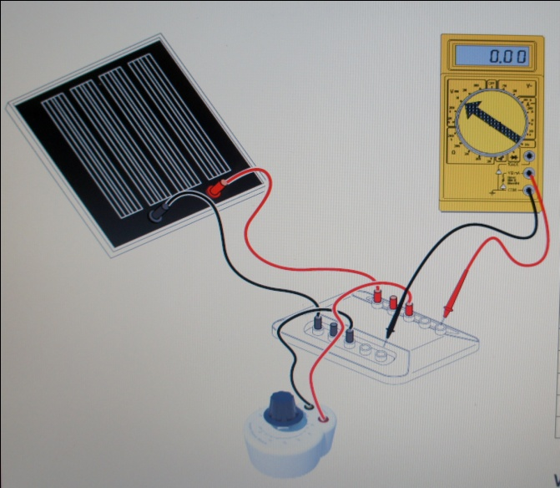

Mentors should assist students in filling the tables and taking measurements.

Remember mW is the unit for power, which can be calculated according to this formula: p (mW) = mV x mA

**Without Fan: Heating up**

|  |  |  |  |
| --- | --- | --- | --- |
| **Time (s)** | **mV** | **mA** | **mW** |
| **0** |  |  |  |
| **30** |  |  |  |
| **60** |  |  |  |
| **90** |  |  |  |
| **120** |  |  |  |
| **150** |  |  |  |
| **180** |  |  |  |

**With Fan: Cooling down**

|  |  |  |  |
| --- | --- | --- | --- |
| **Time (s)** | **mV** | **mA** | **mW** |
| **0** |  |  |  |
| **30** |  |  |  |
| **60** |  |  |  |
| **90** |  |  |  |
| **120** |  |  |  |
| **150** |  |  |  |
| **180** |  |  |  |

**Analyzing the result:**

Using the data from the 2 tables, make a graph of Voltage versus Time starting with data from the first table and continue with data from the second table.

Here is how the graph should look like.



Note 1: Do not display the above graph with the projector; instead display the graph that they come up with. Have them determine where the heating and cooling parts are.

Note 2: If the classroom lacks a computer or students are uncomfortable with this assignment, mentor is responsible for plotting the points on an excel sheet and display the graph on the board using the projector.

**Reflection: What IF???**

Have the students speculate on the following hypothetical questions.

1. What if it rained on a solar panel and then the sun came out. Would the solar panel produce more power output after it rained than if it stayed in the sun all day?
2. What if you lived high in the Rocky Mountains of Colorado? Would your solar panels produce more power on a sunny day in the winter than if you lived in South Florida?