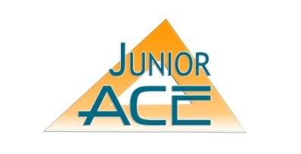
GREEN TERMS
By Joseph Sanford (wdginc@gmail.com )

DEMONSTRATION/DISCUSSION

This module is part of the Engineering and Green Tech path, under the Options. It is to be presented in one session to foment understanding of how to identify and understand the terms which exist to promote Green Technology and Design.

Educational Goals:

Students will:
- Learn some of the myriad of terms involved with Green Technology and Design
- Learn what these terms mean and how they relate to the industry
- Be introduced to these terms so that they can have a context for all the other learning about Green Technology and Design they will do.
Overview: This module consists of a power point with a list of several terms which exist to promote Green Design and Technology. This is by no means an exhaustive list, but it does comprise some of the main terms which help define the Green Community.
This module, being part of the Engineering and Green Tech Path, is mostly meant to be read aloud, understanding the descriptions of the terms and their meanings, and discussed as a group.
Content: The main content consists of descriptions of the different terms, the definitions, and how they relate to the industry.
Time: Approximately 1-1.5 hours. Mentor should foment discussion of each of the terms and relate to the students a context of how these terms came about and how they relate to the industry.
Materials Needed:
- Computer and Projector
Directions: Very simple…run the power point on the projector, follow it, ask questions about what they are seeing, and use the information to introduce the concept of the Green Industry and the need for people to be involved on many different levels to help inform each other and to bring structure to the movement.

Topics to Discuss:
Discuss just exactly what Green Technology is and how it works in the building industry

Discuss the reasons what each term means and how it relates
As a discussion point, ask if any of the students have any knowledge of any of these terms and how they understand the terms to mean and how they are used
If your class seems especially bright, perhaps have them do research on the inclusion of Green Building Practices in the construction process and the impacts of that inclusion, both positive and negative, and how these organizations might help.
Mentor Notes: This module is intended to introduce the student to the wide world of Green Technology, how it is growing, and how terms are developed to help educate and explain the industry.

