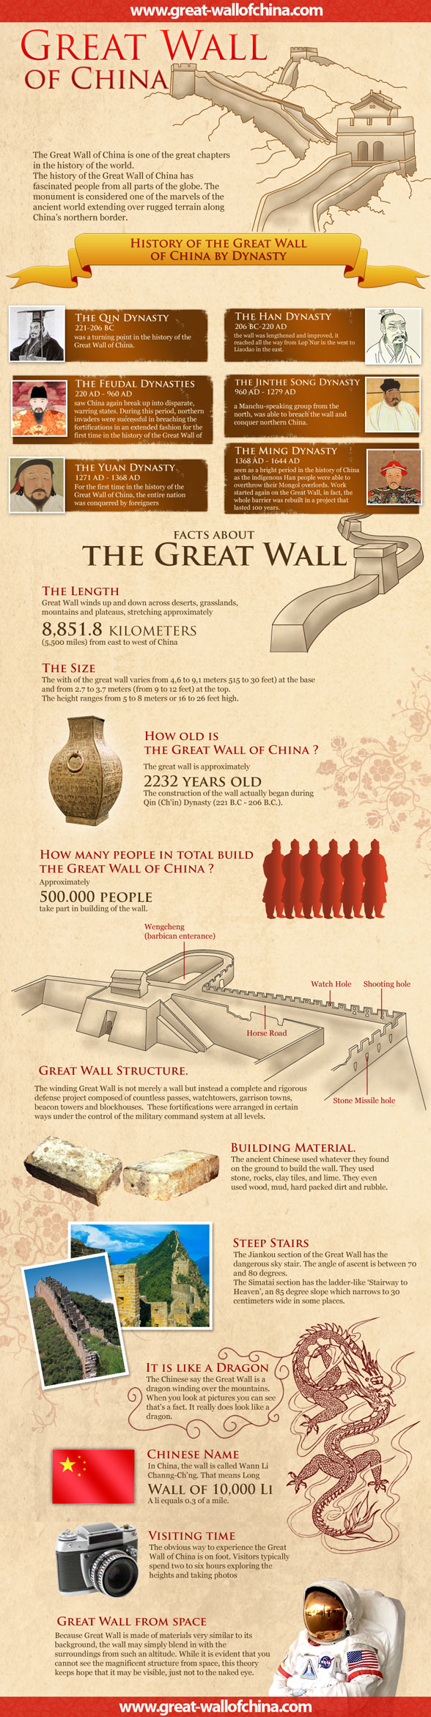
GREAT WALL OF CHINA THOUGHTS
* The Great Wall, is included in the list of the "Seven Medieval Wonders of the World
* The Wall was made a UNESCO World Heritage Site in 1987.
* The Chinese have a saying, roughly meaning "you're not a real man if you haven't climbed the Great Wall".
But for what is the Wall Great?
It's not, however, an easy question to answer. Let's just start from the Wall's length and building time.
The Earliest Wall, Around 700 B.C.
The first wall was arguably built around seven centuries B.C. by the Chu State (B.C. 770 ~ 476). Most scholars also believe that the Qi State, a prince like the Chu State, also built its wall about the same time of the wall of the Chu State. Nevertheless, not until hundreds of years later did many other princes, known as warring states, begin to build their own walls. This time was known as the Warring States Period (B.C. 475 ~ 221).
Warring States Period was a turbulent period, when the ruling power of the Zhou Kingdom (till 221 B.C.) was declining. In this background, the defense of one state against attack from others became significant. Because walls proved the best screen to chariots, main arms of that time, relatively powerful states, also known as "the Seven Powers", began to build walls along their borders. These walls are called pre-Qin Walls by historians today. And they are predecessors of the Great Wall.
The First Great Wall, Around 200 B.C., Length, 10,000 Li, i.e. 5,000 Kilometers
After the Qin Dynasty had established and unified the whole China in 221 B.C., the Emperor combined the walls constructed by the Zhao, Yan and Ex-Qin States, mainly to fend off the intrusion of the flying cavalry known as Mongols, from the Xiongnu in the north, and thus formed the first wall that exceeded 10,000 li or 5,000 kilometers. The Great Wall, short for the Great Wall of 10,000 li, thus had its name.
Three Great Walls
Many people know about the Great Wall. But maybe fewer know that there are actually three such Great Walls, the longest built during the Han Dynasty (206 B.C. ~ A.D. 220), following the Qin Dynasty, exceeding even 20,000 li. The Great Walls of the Han and Qin Dynasties still have remains, but most of them no longer exist. The Wall we see today was largely built during the Ming Dynasty (1368 ~ 1644). It stretches over 12,000 li. By the Great Wall, people now usually mean the Great Wall of the Ming Dynasty. In Chinese history, more than twenty states and dynasties built their own walls. Counted together, they come to a formidable length of 100,000 li, or 50,000 km (31000 miles).
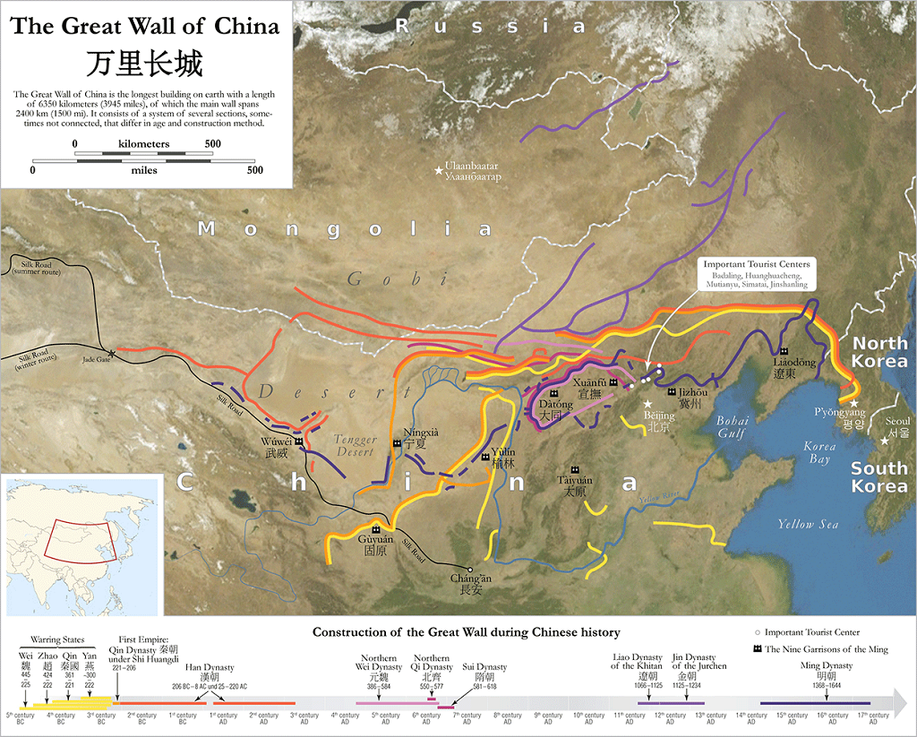

Great Military Works
Many people have climbed the Great Wall. They may have seen enjoyable and peaceful life up and down the Wall. They may have also been amazed at the beautiful scenery from the Wall and felt proud at a peak. But all these might fail to remind people that the Wall was once product of war: it was fortification in ancient times.
The Wall falls into the scope of fortification, a military engineering science now still being researched that mainly deals with how to enhance the attack or defense capacity of a position to its terrain before or during the battle. Devised as a permanent giant of defense works, in the process of construction, besides appropriate materials and sound structures adopted to make it solid enough to survive all weathers, the Wall required also thorough consideration of how the enemies might attack and of how to counterattack.
Here special mention is made that one or more gates in the Wall which made certain angles, sometimes 90 degrees, to the Wall, preventing the enemy from riding in straightforward, able to attack at speed. They had to slow down and make themselves vulnerable to attack. This also was a function of the Wall to defend the country.

Building
The building of the Wall was also matter-of-fact. In strategic places, double- or multiple walls were adopted to thicken and enforce the defense. For example, to protect its capital, present Beijing, the Ming Dynasty constructed three walls to the north and west of the city and between the walls disposed barricades to hold up enemy cavalries.
Fight towers were also designed out of the consideration of defense. They were first adopted on the Great Wall of the Ming Dynasty. Evenly distributed on the Wall every 300 or 400 meters, they made it quick to round up a force at a certain point. More importantly, their distribution on the Wall was linked to the effective range of the arrow of the day, also 300 to 400 meters, so that soldiers taking a commanding position on the tower could reach enemies coming from the sides.
Architecture Wonder
The Great Wall is also an architectural wonder of the ancients. It was so big a project that it was impossible to build it in uniform forms and materials in different places. So we can see parts of different materials and various shapes, which were depended on local resources. If you have the chance to walk thought the whole route of the Wall, you would see how diverse the Wall is.
The Ming Dynasty was the last dynasty that ever built the wall. Since then, the wall gradually fell out of use as fortification. It no longer fitted new forms of wars and could hardly resist weapons that were more powerful. Its function gradually faded, and eventually it became a memory of yesterday.
But the Wall still stands there, as it was. It traverses the north part of China, being a masterpiece of both the architecture and the war art of ancient China. Having also witnessed the rise and fall of dynasties, it tells a glorious history created by its people.

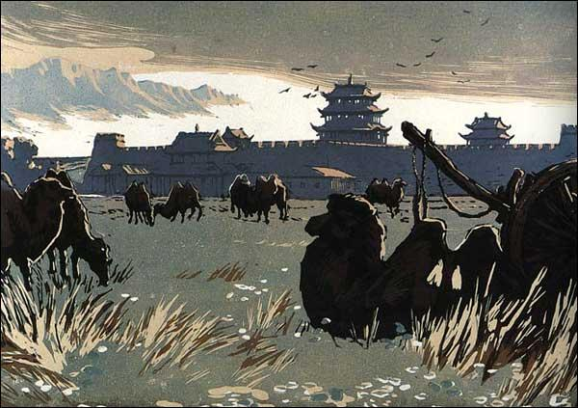

How was the Great Wall of China defended ?
China's rulers knew that a defence system to protect the country from invaders needed to be substantial. But how substantial would it need to be? A lengthy wall was constructed over time, but its length and its height was not the only strategy employed in defending the motherland.
Due to its length, the Great Wall of China could not have men along every inch of its ramparts at once watching out for the Mongols, Turks, Tungnu, and Xiongnu. Even with nine Zhen (military districts) covering the 4100 mile length between the First and Last Doors under Heaven, the defenders held true to Sun Tzu’s adage “He who defends everything, defends nothing.” To prioritize their defense, the Chinese created a method to alert garrisons where attacks were in progress. This took the form of a firelightdefense system within the watch towers.
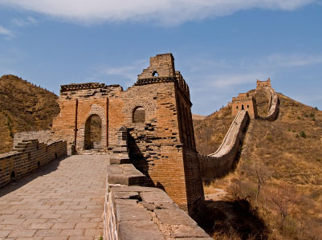

Fire-light defending system of the watch towers.
The Great Wall is not merely one long wall meant to keep invaders out of China. Rather, it is dotted every so many miles with towers, numbering 25,000 in all. These towers served two purposes. First, soldiers could be posted in the tower to keep watch for anyone approaching the wall. To maximize their line of sight, and therefore, the time they had to warn of potential invasions, the towers were built on hilltops.
Second, should an attack come, the soldiers in the tower could light a signal fire. Each tower guard could see either the smoke in the day or the light in the night and start his own fire (the aforementioned choice to build the towers on hilltops also guaranteed both fire products would be visible). This would continue from one tower to the next until every available troop was alerted and ready to defend the wall. Additional messages were also sent via lanterns mounted on long poles and flags.
Soldiers also patrolled on top of the wall from tower to tower to spot any movement the tower guard might miss. The whole length of the Great Wall collectively garrisoned tens of thousands of peasant soldiers by 102 B.C. before it had even finished construction. Wide passages were constructed along the tops of the walls to expedite the movements of large numbers of troops and couriers. This made defending the wall’s prodigious length both logistically and strategically feasible.
Thus, the Great Wall of China was defended by watchful eyes, a system of signal fires, lights, and flags, and an army of brave, dedicated, and an army of observant men who were quick on their feet.

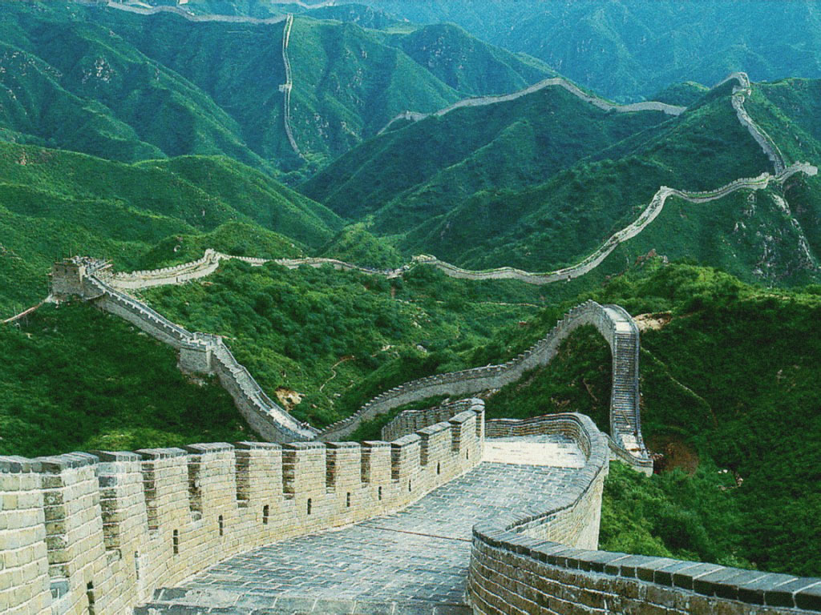

Great Wall Of China Bad Facts.
Created by many different dynasties to protect the Northern border of China, the Great Wall of China still mystifies people today. Often considered the epitome of mankind’s power, this famous wall also has many reasons to be ashamed of itself. Here are some less known facts about the Great Wall of China that are not so noble.
- A Great Failure
The Great Wall of China often didn’t achieve its life purpose. In many areas, the wall was never completed or was low enough to allow easy access for the Mongol armies of Ghengis Khan. This allowed the Mongols to conquer northern China and rule until the Ming Dynasty came into power.
- A Great Injustice

There was a period of time that people actively disapproved of the Great Wall. People viewed it as a sign of a single ruler and an unfair system. People encouraged each other to remove bricks from the Great Wall and keep the bricks on their farms to rebel against the perceived unfairness.

In the pictures at the end, note the steepness of the steps! One would have to be in excellent shape to navigate these day in and day out, to defend the country. But it was done!
