SKYSCRAPERS!
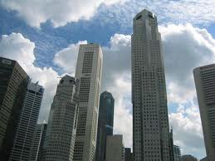
What are Skyscrapers?
They are essentially very tall buildings with many floors in which can be placed offices, restaurants, movie theaters, apartments and condominiums, health clubs, hotels, gardens, swimming pools, and a whole lot more. They are huge buildings, usually several hundred thousand square feet or larger, into the millions of square feet, and are usually sited in urban cores of major cities. They are big enough to have their own subway stations underneath, and helicopters can land on their roofs. Most Skyscrapers have populations in the 3-5,000 person size, but the tallest Skyscraper on earth today can hold an amazing 35,000 people at one time. Can you imagine trying to keep all those people cool, warm, watered and fed? And how many elevators, toilets, water fountains, doors and windows, and light switches does that take? So, where did these giants come from?
Skyscrapers are a fairly modern invention. Starting in the late 19th century, cities around the world were growing. But in the U.S., New York City and Chicago had grown ever more crowded and this demanded new thought as to building design. As the cities became more dense, people started building multiple-story structures to make each square foot of land work more effectively. Essentially, if you could take the land area you had, and multiply it 4 or 5 or 6 times straight up, it was if you could have a piece of land 4 or 5 or 6 times larger than you originally had. With a Skyscraper, that land is multiplied by 50 or 80 or 100 times, straight up. This was allowed by inventions and improvements in engineering design, material strength, building procedures and methods, and innovation in people movement, climate control, and fire and earthquake resistance.

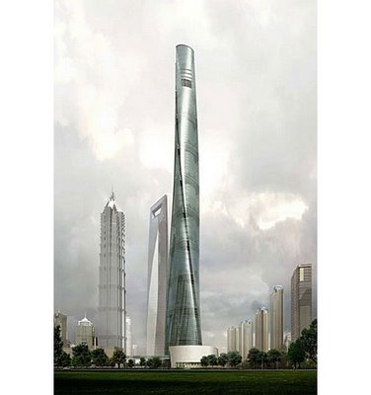As you can imagine, if you can buy a piece of land in a city and then multiply it 100 times vertically, that makes each square foot of land incredibly valuable. This makes everything in the downtown core cost more, for office space, parking, retail stores, and apartments and condominiums. That is why it cost so much more to live in big cities like New York, Chicago, London, and Shanghai, than it does in the country or smaller towns around the world.
As time goes on, Skyscrapers get more and more sophisticated, and more and more expensive. For example, the twin towers in New York in 1972, cost $400,000,000 (Four Hundred Million Dollars). The Burj Kalifa, in 2010, in Dubai, U.A.E., cost over $1,500,000,000 (1.5 Billion Dollars, or 4 times as much—that is 1500 million dollars).
Skyscrapers are a huge financial gamble for the developers, too. It takes about 3-4 years to put the financing together, acquire the land, get the approvals to design and develop the property, and then 4 to 6 years to build it. That represents anywhere from 7 to 10 years to go from start to finish. All the while, the world is changing, the demands for space, the world political climate, and the population is shifting all around, not to mention that the cost for construction changes almost daily. Buildings like this do not get built without there being a profit motive involved, but it is at a very high risk.

Here is a Skyscraper in which each floor rotates around the core independently—the future of buildings?
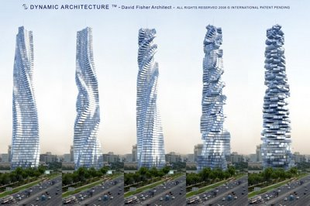
The Dynamic Tower (also known as Dynamic Architecture Building or the Da Vinci Tower) is a proposed 420-metre (1,378 ft), 80-floor tower in Dubai, United Arab Emirates. The tower is expected to be architecturally innovative for several reasons: Uniquely, each floor will be able to rotate independently. This will result in a constantly changing shape of the tower. Each floor will rotate a maximum of 6 metres (20 ft) per minute, or one full rotation in 90 minutes. It will also be the world's first prefabricated skyscraper with 40 factory-built modules. 90% of the tower will be built in a factory and shipped to the construction site.

As an example, when the Burj Kalifa, the tallest building in the world, was conceived, the world economy was expanding and people everywhere were excited about the future. Since that time, many things have changed, most notably the world economic collapse of 2007-2011. As a result, when the Burj Khalifa opened in January 2010, only about 70 of 900 condominium unit were sold, and most of the office space was empty. It is still this way. The luxury hotel, which takes up 35 floors of the building, has only opened the observation deck and is not in business at all.
Thus, the tallest building in the world is, essentially, a ghost tower. Hardly anyone is in it, and the entire project may go bankrupt. Such is the world of the Skyscraper Developer. What will probably happen, though, is that it will be offered for sale at a reduced cost to cover the basic cost of construction, and some investment group somewhere in the world will buy it and open it when the world economy recovers and they will make billions of dollars on that building. That is just the way real estate works. But, life goes on, and cities will continue to grow, and more tall buildings will be built, and people will work, live, play, eat, and exercise in them.

SKYSCRAPER FOUNDATIONS
The foundations for Skyscrapers are the key to the overall success of the structure. These buildings weigh millions of tons, and also are very tall so, like the roots of a tree, the foundations must go very deep and sit on rock.
Underneath most all soils on Earth, is a layer of what we call “bedrock”. It is called this because it forms a “bed” of rock which does not move and which can bear enormous weight. Fortunately, most bedrock is fairly close to the surface, from around 200’ feet below to the actual surface itself.
By placing multiple drilled columns of concrete and steel under the structure down to the bedrock, the building can rest on solid support and not move vertically. Also, by drilling into undisturbed soils above the bedrock, the soil can provide resistance to lateral, or sideways, movement, which keeps the tower from leaning. It is like putting in a fence post—you drill a hole down into the soil, put the post in and pour concrete around and under it, and then fill the soil back in at the top. The fence post is very strong and won’t sink or move side to side. This is called in Structural Terms, a cantilevered column.
When you drill the foundations of a Skyscraper, you are essentially building a cantilevered column, with both strong vertical support and great lateral support. The strongest buildings keep the structural columns in the building aligned with the drilled ones below, thus having uninterrupted vertical support from the top to the bottom. Here is a diagram of the Burj Khalifa foundation, to show what this looks like:
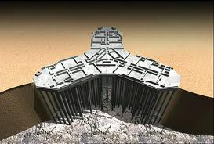

QUESTIONS:
1) Why Build Skyscrapers? What do they offer that other shorter buildings do not?
2) How has the development of the Skyscraper affected our cities and how we live?
3) How did the Skyscraper affect the cost of land in the cities?
4) What one engineering invention first allowed the Skyscraper to become a viable building form?
5) How are they supported so they don’t sink or fall over?
6) How do they resist the wind way up there?
7) How about earthquakes?
8) Where is the tallest Building in the world located? How tall is it?

HEIGHT COMPARISON GRAPHIC
http://skyscraperpage.com/diagrams/?searchID=200

YOU-TUBE VIDEOS SERIES ON HISTORY OF THE SKYSCRAPER
Five You-Tube videos on Skyscrapers from Big, Bigger, Biggest Channel 5 Nat’l. Geo.
http://www.youtube.com/watch?v=CfPe9YJTIU4
http://www.youtube.com/watch?v=Fh90HN5HYxQ
http://www.youtube.com/watch?v=YhQlaymegVI
http://www.youtube.com/watch?v=vBmx_rfQc3s
http://www.youtube.com/watch?v=Q2o6jBcjBL0
These deal with the 7 great scientific and engineering breakthroughs which allowed the development of the modern skyscraper.

1) The Elevator vs. Stairs, which limited height to 5 stories
Equitable Life Building N.Y. 1870 (43 m/142 feet tall)

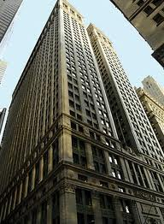

2) Steel Structure vs. Load-Bearing Masonry
Fuller Flatiron Building N.Y. 1902 (87 m/287 feet tall)
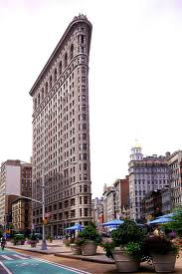

3) The Advent of Air Conditioning/HVAC
United Nations Building N.Y. 1947 (168 m/554 feet tall)
Also allowed larger floor plates as proximity to open windows no longer necessary

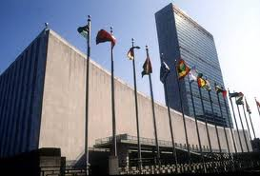

4) Pre-Fabricated Construction to decrease building time and make buildings cost less to build
World Trade Center Towers N.Y. 1972-73 417 m/1376 feet tall)

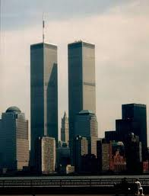
5) Exoskeleton Design to fight wind sway
Sears Tower Chicago 1973 (442 m/1458 feet tall)
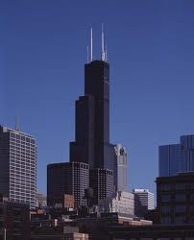

6) Earthquake Resistance Improved by using flexible joints in structure
Taipei 101 Building Taiwan 2004 (509 m/1680 feet tall)

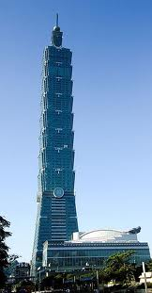

7) Fire Safety Improvements using areas of refuge and smokeless stairways
Burj Khalifa Building Dubai, UAE 2010 (830 m/2739 feet tall)
This building incorporates all of the other advancements into one structure, and adds the areas of refuge and smokeless stairways to improve life safety in case of fire

