SKYSCRAPERS!
Joseph Sanford
wdginc@gmail.com)

SKYSCRAPERS!

Educational Goals:
- Introduce students to the concept of the Skyscraper
- Define what a Skyscraper is and how it works
- Examine the history of the development of the Skyscraper, and the engineering advances which made it possible
- Understand how Skyscrapers are built, how they resist wind, earthquake, and fire, and what they cost
- Examine the impact the Skyscraper has had on modern society
Overview: This module introduces the Skyscraper to the student, explains what occurred to allow this building type to develop, how they have changed the way we live in society, and examines the incredible engineering advances developed for this building type we take for granted today.
Content: A graphic showing relative heights of the world’s skyscrapers, and their timeline of construction and location; a 5-part you-tube video series on the significant innovations over the last 140 years which allowed the Skyscraper to become a viable building type, and how that changed the way we think about cities; a short introduction in a word document to explain a bit about them and their economics; and some questions to be asked before the videos are viewed.
Time: Approximately 1.5 to 2 hours to do the intro, ask the questions, view the videos (about 45 minutes on the You-Tube videos, the graphic is very fun, but would probably leave it up to refer to as it could take a month to go through all the buildings there), re-ask the questions, and do Q and A.
Materials Needed:
- Computer
- Word docs
- Internet connection
Directions: Start with the Word Doc Intro piece, to familiarize the students with the concept. Perhaps ask the class what they know about Skyscrapers first, and get some definitions from them. Then, ask the questions at the end of the intro piece before watching the videos. Tell the students you will ask these questions again after you view the videos.

Next, pull up the graphic which details relative heights of all the Skyscrapers in the world and compares them, with heights, dates of construction, and location supplied. Discuss how all the different buildings look, and where in the world are they. If you have a world map, it is neat to point out the countries which are building such tall structures. (Most of the kids have never heard of Dubai, and will not know where it is, so it helps to show it on a map)
Topics to Discuss:
- What would it be like to be in the top of these tall buildings on a windy day or in an earthquake
- These kids were 2 years old when 9-11 happened at the World Trade Center in New York, so they did not experience that day. However, that is a great example of how vulnerable Skyscrapers are to terrorism, and what designers are doing now to prevent the collapse of new structures (mostly they are putting in more columns, and making the structure out of concrete vs. steel, which does not burn nor does it collapse in a fire)
- The Burj Khalifa is almost a half a mile high, and can hold 35,000 people. That is the size of a small town. When do they think it will become unviable to have taller buildings with more people in them? Considerations are the ability to get everyone in or out quickly for work, or for a fire. How to get water up to the top, and how to heat and cool the building with that many people in it. Other thoughts are just the sheer weight of the structure and the cost to build one, as well as how much of a shadow does it put on the ground over other buildings and streets and parks, etc.
- Did they know that some of these buildings are so tall it can be cool and cloudy at the base, and sunny at the top above the clouds? So weather plays a part of the design, as well, as the top may be much warmer than the bottom, causing stresses to the structure, which have to be accounted for in the design.

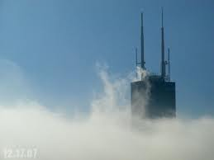

Explain how Designers put huge counterweights in the crowns of tall buildings nowadays, to offset the swaying action which occurs during earthquakes. Here is one which is inside the Taipei 101 Building in Taiwan. It weighs an incredible 400 tons, and sways opposite to the building when an earthquake happens, to dampen the oscillations which happen during those events to keep the building stable.

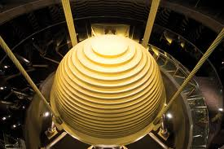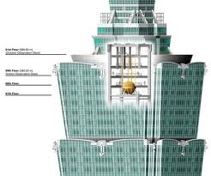

Mentor Notes: It is suggested that you study the graphic and watch the videos before you do this module, to prepare and educate yourself about Skyscrapers. There is much more to know and talk about, so feel free to follow any interest you have online or in other research and add it to this basic package to make it more targeted to your classes. Some suggestions are a study on how wind affects tall buildings, how does the glass skin stay on the building, how do they put in the foundation for the buildings, how do elevators work, what about fire in a tall building, what are the new advances in design coming along for the future?

