GEMASOLAR
SOLAR POWER GENERATION PLANT
Seville - Spain

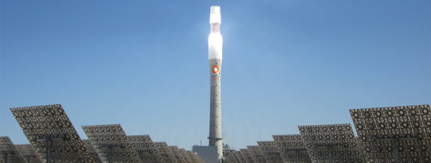
Gemasolar is the first commercial-scale plant in the world to apply central tower receiver and molten salt heat storage technology. The relevance of this plant lies in its technological uniqueness, since it opens up the way for new thermosolar electrical generation technology.
Characteristics of Gemasolar:
- Rated electrical power: 19.9 MW
- Net electrical production expected: 110 GWh/year
- Solar field: 2,650 heliostats on 185 hectares
- Heat storage system: the molten salt storage tank permits independent electrical generation for up to 15 hours without any solar feed.
The prolongation of the plant's operating time in the absence of solar radiation and the improvement in efficiency of the use of the heat from the sun makes Gemasolar's output much higher than that which is delivered by other technologies in a facility with the same power.
The notable increase in the plant's power efficiency guarantees electrical production for 6,500 hours a year, 1.5 to 3 times more than other renewable energies. The plant will thus supply clean, safe power to 25,000 homes and reduce atmospheric CO₂ emissions by more than 30,000 tons a year.
The power generated by Gemasolar will be sent through a high-tension line to the substation of Villanueva del Rey (Andalusia, Spain), where it will be injected into the grid.

Central tower technology
The inclusion of a novel molten-salt heat storage system permits the production of electricity in the absence of solar radiation.
The heat collected by the salts (capable of reaching temperatures above 500º) generates steam and produces electrical power. The surplus heat accumulated during sun hours is stored in the molten-salt tank.
In this way, Gemasolar can produce electrical power 24 hours a day for many months of the year.

Central-tower technology
Torresol Energy has pioneered the application of technological solutions for central tower and heliostat plants such as the high concentration receiver system and high-temperature molten-salt storage system.
How the technology works
In central tower plants, heliostats (flat mirrors) reflect solar radiation onto a receiver located at the top of a tower through which molten nitrate salts flow. The salts are impelled from a ‘cold tank’ to a receiver located at the top of a tower where they are heated to 565ºC. The hot salts then descend to the heat exchanger and generate water vapor.
In surplus-energy conditions, in which the heat radiation received is more than sufficient to cover the turbine's demand, some of the salts are stored in a hot tank, saving the heat to be used when solar radiation is low. The salts transfer the stored heat and continue to generate electrical power.

Video for Gemasolar Tower Construction:

http://www.torresolenergy.com/TORRESOL/central-tower-technology/en

VALLE 1 AND 2

Cylindrical-parabolic collector technology
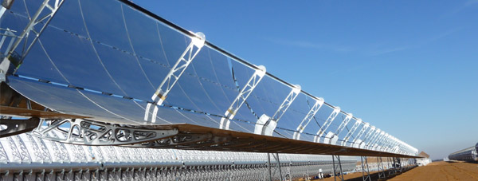
Torresol Energy builds plants with cylindrical-parabolic collector technology which include a molten-salt heat storage system, enabling a very high annual coefficient of use.
How the technology works
These plants are comprised of loops (or arrays) of parabolic mirrors that concentrate solar radiation in a central collector pipe through which thermal oil circulates and is heated to almost 400ºC.
This oil is transferred to a heat exchanger, where:
- It vaporizes water which, in a steam turbine, drives a generator that injects electrical power into the grid
- Surplus power can be used to heat liquid nitrate salts and store the heat in a hot tank, making it possible to generate electricity even in the absence of sunlight.
Torresol Energy operates two cylindrical-parabolic collectors in the south of Spain, Valle 1 and Valle 2.
These plants each have:
- 50 MW of power
- One solar field of 5,000,000 s.f. of SENERtrough®-type collectors
- A molten-salt heat storage system, supplying electrical power for up to seven hours without solar radiation.

