Build a Solar Farm
By Zai Vang (zaivang@live.com)

Educational Goals:

This lesson demonstrates methods to arrange multiple solar panels in series and parallel configurations in order to study the voltage, current and power generated. It is designed to be a simulation of a commercial solar farm in model scale where students learn the potential of solar power as a mass energy source. At least two (2) of the same type of solar panels are needed. More than two solar panels can also be accommodated and is encouraged.

Learning Outcomes:

Students are shown that solar panels, like common flashlight batteries, can be arranged in series and parallel configurations with the same general outcomes.

Students come to understand that:

1. Solar panels in series generate more voltage with the same amount of current.
2. Solar panels in parallel generate more current with the same amount of voltage.
3. Solar panels can be arranged in any combination of series and parallel arrangements to generate the desired voltage, current and power required by a particular application.

Description:

Students first wire two solar panels in series and measure the voltage, current and power going into a fixed resistor load at various tilt angles. This is followed by wiring the same solar panels in parallel and repeating the measurements. Data are taken for later analysis. Additional exercises are performed in the “What If” section to query student’s understanding of how solar panels can be arranged in different series-parallel groups to power popular portable electronic devices.

Time: 2 hours

Materials Needed:

2 - Solar panels (or more if desired)
1- Goose neck table lamp (two if necessary)
1 - Protractor
1 - 100 ohm potentiometer
3 – Red hookup leads
3 – Black hookup leads
1 – Circuit Board Module Base

Direction

- Connection in Series:

1. Set the potentiometer to 100 ohms.
2. Set the multimeter dial to DC Volts with a range of at least 10 VDC.
3. Place the solar panels flat on the table facing straight up.
4. Shine the table lamp directly on the solar panel.
5. Record the voltage.

Record the measurements:

Resistance | Volts | Amps | Watts
100

Note: The set up should look like this:

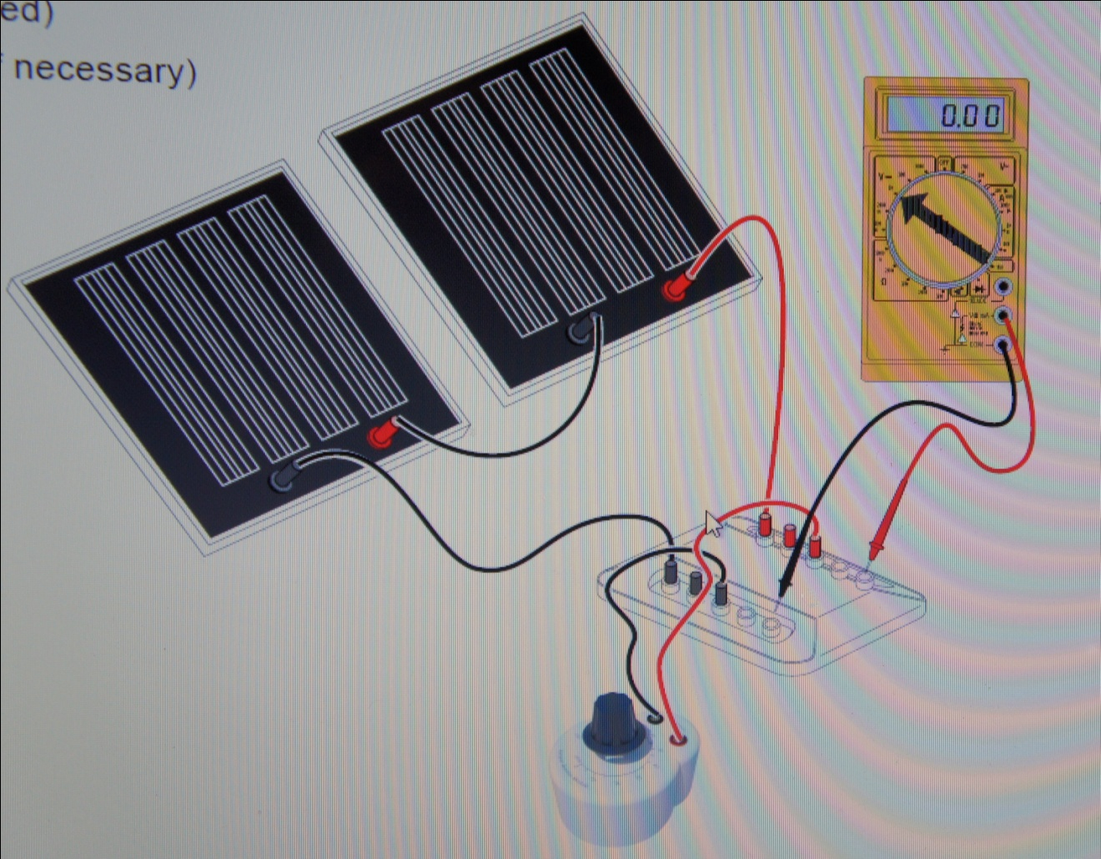

- Connection in Parallel:

10. Set the potentiometer to 100 ohms.
11. Set the multimeter dial to DC Volts with a range of at least 10 VDC.
12. Place the solar panels flat on the table facing straight up.
13. Shine the table lamp directly on the solar panel.
14. Record the voltage.

Record the measurements:

Resistance | Volts | Amps | Watts
100

Note: The set-up should like like this:

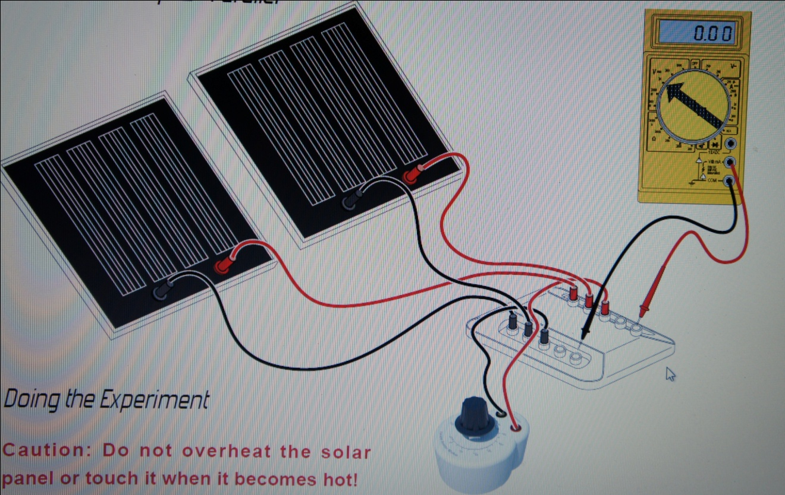

Analyzing the Result:

What is the difference between circuits in series and parallel?
Why is it important to know the difference?
Give an example.

What If ???

What if your class decided to build a large model solar farm? How would you arrange the solar panels in series and parallel to power or charge up the following types of devices?

• An IPod
• A Cell Phone
• A Large Portable Radio (Boom Box)
• A Laptop Computer

Assume that each solar panel is rated at 3 volts and 0.100 amps (100 milliamps). You are allowed to have as many panels as you want, but you will be judged on the minimum number of panels you use, so don’t use more than you need. Once you think you know the answer you are to sketch it on paper and describe in writing with some math to support it as to why it will work.

Solar Farm Problem #1 – Charging Your IPod
A typical IPod (of any model) requires 6 volts and 0.2 amps (200 milliamps) for charging. How many solar panels and in what series-parallel configuration will you need to charge it?

Solar Farm Problem #2 – Charging Your Cell Phone
A typical cell phone requires 9 volts and 0.4 amps (400 milliamps) for charging. How many solar panels and in what series-parallel configuration will you need to charge it?

Solar Farm Problem #3 – Powering a Large Portable Radio (Boom Box)
Because a Boom Box is so loud it takes a good deal of battery power when it’s ON. Assume that it requires 15 volts and 0.8 amps (800 milliamps) to keep it blasting out your favorite tunes. How many solar panels and in what series-parallel configuration will you need to charge it?

Solar Farm Problem #4 – Powering a Laptop Computer
A neat thing to do would be to keep your laptop computer fully charged at all times so that you could use it to surf the web or Twitter to your friends without its battery going dead. Assume that your laptop needs 12 volts at 1.2 amps (1200 milliamps) to stay fully charged at all times. How many solar panels and in what series-parallel configuration will you need to charge it and keep it charged?

